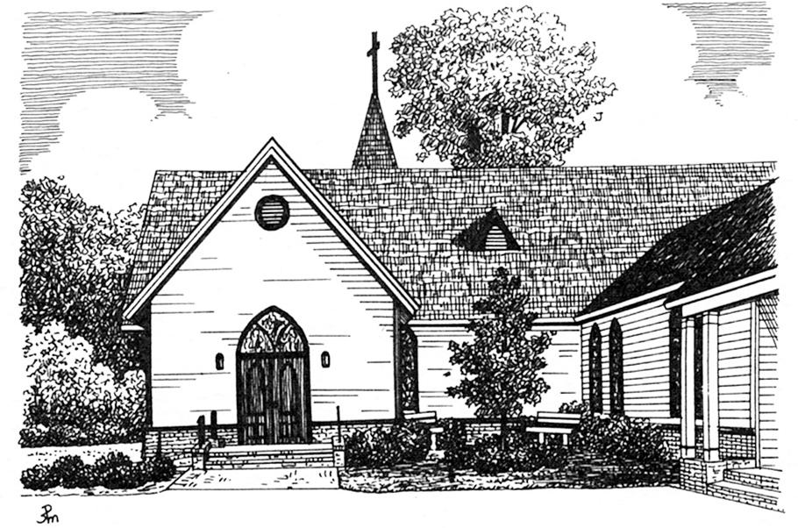
St. Margaret’s Episcopal Church
1601 Pleasant Plains Road
Annapolis, MD 21409
(410) 974-0200
info@st-margarets.org
www.st-margarets.org
Guidelines/Application for Baptism 2017-18
Congratulations on considering St. Margaret’s as the community through which your child will be baptized into Christ’s body. We welcome all who wish to be baptized into the Body of Christ at St. Margaret’s, and we will make every effort to make you feel comfortable as an active member of our faith community.
Our baptisms take place in the context of Sunday worship (except for the Easter Vigil), typically at either the 9 a.m. or 11:15 a.m. services. We do not perform private baptisms.
Choosing Sponsors (or Godparents): Sponsors must be baptized, active members of a Christian community. Traditionally, two or three sponsors are chosen.
Pre-baptismal Formation: to enhance your experience of St. Margaret’s, this one-time class will prepare you for the baptism service and for participation in Christ’s Body, the Church. This instruction usually takes place before the baptism date on a Saturday morning from 10 a.m. to noon. You do not have to take the class if you have already had a child baptized at St. Margaret’s.
Please select your desired Baptism date and class:
Sunday, Sept. 10 Baptism; Sat., Sept. 9 Class Sunday, Nov. 5 Baptism; Sat., Nov. 4 Class
Sunday, Jan.14 Baptism; Sat., Jan.13 Class Sunday, Feb. 11 Baptism; Sat., Feb. 10 Class
Saturday, March 31 Easter Vigil Baptism @ 8 p.m.; Sat., March 31 10 am Class
Sunday, April 8 Baptism; Sat., April 7 Class Sunday, May 20 Baptism; Sat. May 19 Class
Please select your preferred time for the Baptism service: 9:00 a.m. 11:15 a.m.
Full Name of Candidate: Male or Female?
Date of Birth Place of Birth:
Home Address:
Home Phone: Work or Cell Phone:
Email: Church Affiliation:
Full Name of Parent 1: Full Name of Parent 2:
Full Names and Addresses of Sponsors (Godparents): If more than two, please list on the back.
(1) ___________________________ (2) ________________________
___________________________ ________________________
___________________________ ________________________

