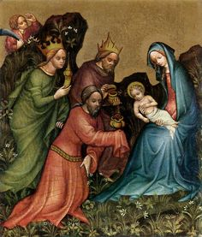

Epiphany Sunday
Sunday, January 5, 2020
9:00 & 11:15 a.m.
Holy Eucharist Rite II

.

Welcome to St. Margaret’s Episcopal Church

If you are visiting us for the first time, let us offer you an especially warm welcome. We hope that you will enjoy worshiping with us. If at any moment in the service you are not sure what to do, ask any of your neighbors in the congregation—they will be happy to help you. We would like to continue our relationship with you, so please fill out a visitor card (found in the pew racks) and drop the card in the collection plate or hand it to one of the clergy or ushers.
Formation

We provide Sunday School and Christian formation to children from ages 3 to 18 from Sept. – May. Note: There will be no Sunday School for children this morning because of the Epiphany Pageant. While children are always welcome at all services, professional nursery care for children ages six weeks to four years is provided from 8:45 a.m. to 12:30 p.m. in the Nursery (downstairs in the church’s annex building). Children’s Chapel is offered during the first part of the 9 a.m. service for children from ages three to second grade. The children leave the nave during the sequence hymn following behind the cross which will come down the aisle and then go into the downstairs annex classroom with the children rejoining their parents at the Peace. Adult Formation is also offered during the 10:15 a.m. to 11 a.m. hour periodically.
Communion

All are welcome to receive bread and wine during communion, including children. To receive bread, place your
hands palms-up at the communion rail. To receive wine, assist the Eucharistic Minister in guiding the chalice to your lips,
or you may intinct by dipping the bread in the wine. If you do not wish to receive the bread or wine, place your
arms across your chest to receive a blessing. Gluten-free wafers are available. Indicate your request by first extending
your hands palms down when at the communion rail. The square wafers are kept in a separate holder, and you are i
nvited to take one from this holder.
Liturgy and Music

The liturgy and music for today is from The Book of Common Prayer, the 1982 hymnal, and other resources as noted.

Cover Painting: Adoration of the Magi, Austrian Renaissance, ca. 1410

The Rev. Peter W. Mayer, Rector * The Rev. Patti Sachs, Assistant Rector
Jim Douglas, Director of Music
1601 Pleasant Plains Rd, Annapolis, MD 21409 * 410-974-0200 * www.st-margarets.org
Emergency Pastoral Number: 443-837-5463

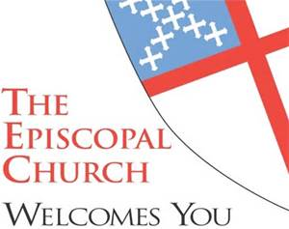
Epiphany Sunday
Sunday, January 5, 2020
9:00 & 11:15 a.m.
The Holy Eucharist Rite II

Prelude

The people stand as able.

Hymn Angels from the realms of glory Regent Square

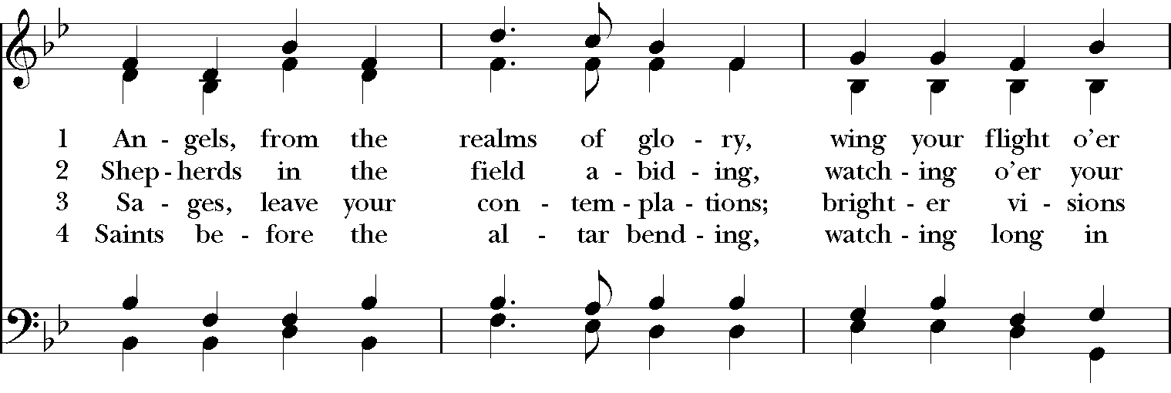
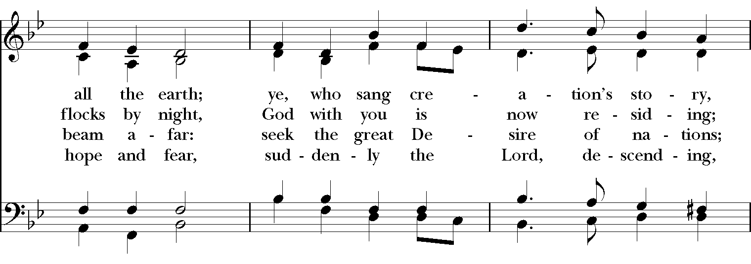
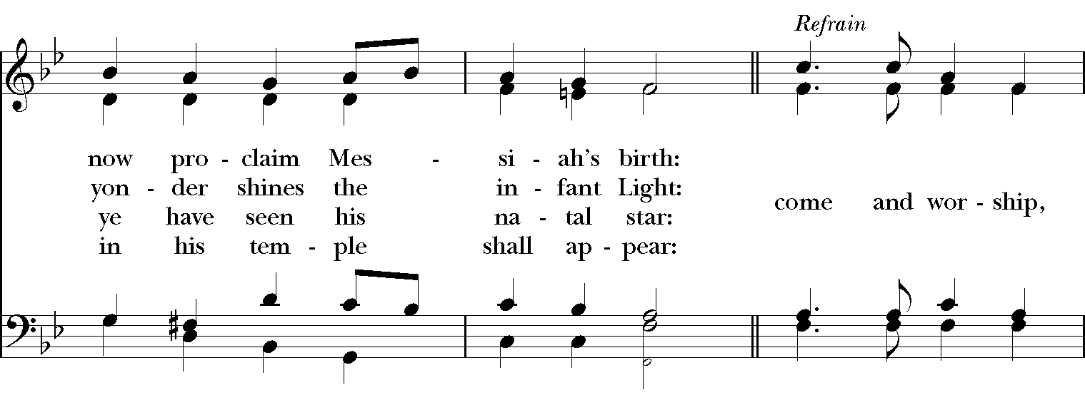
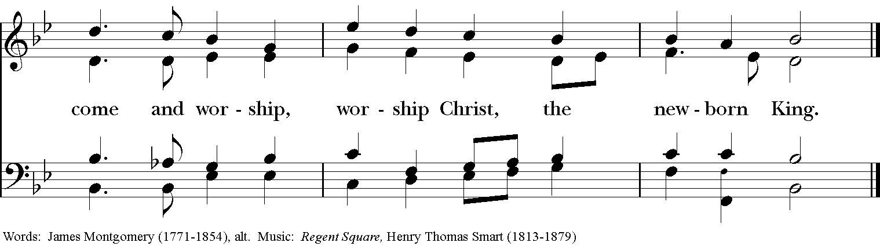

The people remain standing as they are able.

Opening Acclamation

Celebrant Blessed be God: Father, Son, and Holy Spirit.
People And blessed be God’s kingdom, now and for ever. Amen.

Collect for purity

Celebrant Almighty God, to you all hearts are open, all desires known, and from you no secrets are hid:
Cleanse the thoughts of our hearts by the inspiration of your Holy Spirit, that we may perfectly love you, and
worthily magnify your holy Name; through Christ our Lord. Amen.

Song of Praise Allein Gott in der Höh

Collect for the Day

Celebrant The Lord be with you.
People And also with you.
Celebrant Let us pray.

O God, by the leading of a star you manifested your only Son to the peoples of the earth: Lead us, who know you now by faith, to your presence, where we may see your glory face to face; through Jesus Christ our Lord, who lives and reigns with you and the Holy Spirit, one God, now and for ever. Amen.

The people are seated.

First Lesson Isaiah 60:1-6

A reading from the prophet Isaiah.

Arise, shine; for your light has come,
and the glory of the Lord has risen upon you.

For darkness shall cover the earth,
and thick darkness the peoples;

but the Lord will arise upon you,
and his glory will appear over you.

Nations shall come to your light,
and kings to the brightness of your dawn.

Lift up your eyes and look around;
they all gather together, they come to you;

your sons shall come from far away,
and your daughters shall be carried on their nurses' arms.

Then you shall see and be radiant;
your heart shall thrill and rejoice,

because the abundance of the sea shall be brought to you,
the wealth of the nations shall come to you.

A multitude of camels shall cover you,
the young camels of Midian and Ephah;
all those from Sheba shall come.

They shall bring gold and frankincense,
and shall proclaim the praise of the Lord.

Lector The Word of the Lord.
People Thanks be to God.

Gradual (read responsively by whole verse) Psalm 72:1-7, 10-14

1 Give the King your justice, O God, *
and your righteousness to the King's Son;

2 That he may rule your people righteously *
and the poor with justice;

3 That the mountains may bring prosperity to the people, *
and the little hills bring righteousness.

4 He shall defend the needy among the people; *
he shall rescue the poor and crush the oppressor.

5 He shall live as long as the sun and moon endure, *
from one generation to another.

6 He shall come down like rain upon the mown field, *
like showers that water the earth.

7 In his time shall the righteous flourish; *
there shall be abundance of peace till the moon shall be no more.

10 The kings of Tarshish and of the isles shall pay tribute, *
and the kings of Arabia and Saba offer gifts.
11 All kings shall bow down before him, *
and all the nations do him service.

12 For he shall deliver the poor who cries out in distress, *
and the oppressed who has no helper.

13 He shall have pity on the lowly and poor; *
he shall preserve the lives of the needy.

14 He shall redeem their lives from oppression and violence, *
and dear shall their blood be in his sight.

Epistle Ephesians 3:1-12

A reading from Paul’s letter to the Ephesians.

This is the reason that I Paul am a prisoner for Christ Jesus for the sake of you Gentiles-- for surely you have already heard of the commission of God's grace that was given me for you, and how the mystery was made known to me by revelation, as I wrote above in a few words, a reading of which will enable you to perceive my understanding of the mystery of Christ. In former generations this mystery was not made known to humankind, as it has now been revealed to his holy apostles and prophets by the Spirit: that is, the Gentiles have become fellow heirs, members of the same body, and sharers in the promise in Christ Jesus through the gospel.

Of this gospel I have become a servant according to the gift of God's grace that was given me by the working of his power. Although I am the very least of all the saints, this grace was given to me to bring to the Gentiles the news of the boundless riches of Christ, and to make everyone see what is the plan of the mystery hidden for ages in God who created all things; so that through the church the wisdom of God in its rich variety might now be made known to the rulers and authorities in the heavenly places. This was in accordance with the eternal purpose that he has carried out in Christ Jesus our Lord, in whom we have access to God in boldness and confidence through faith in him.

Lector The Word of the Lord.
People Thanks be to God.

The people stand as they are able.

Hymn As with gladness men of old Dix

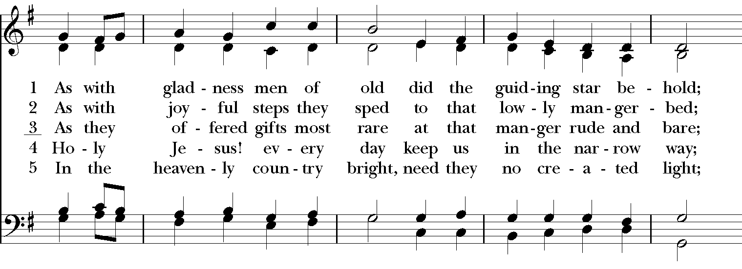
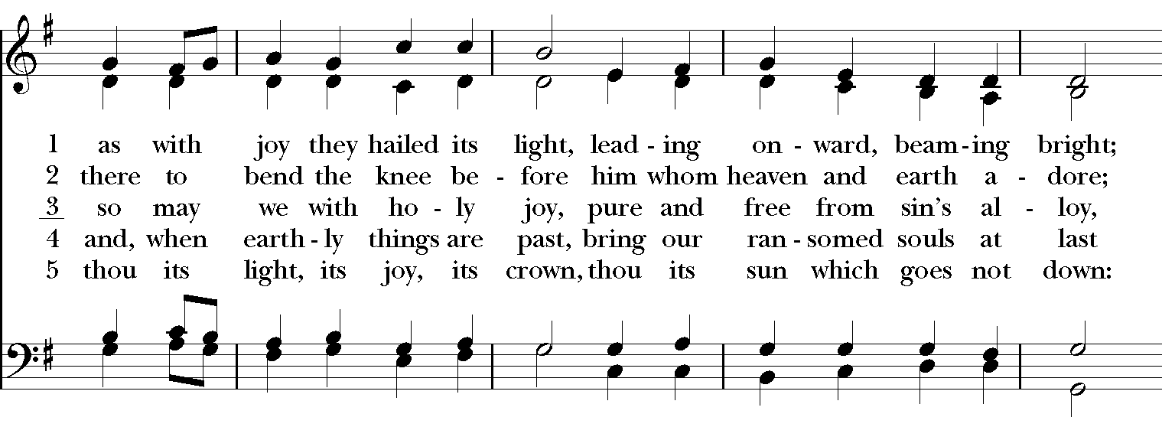
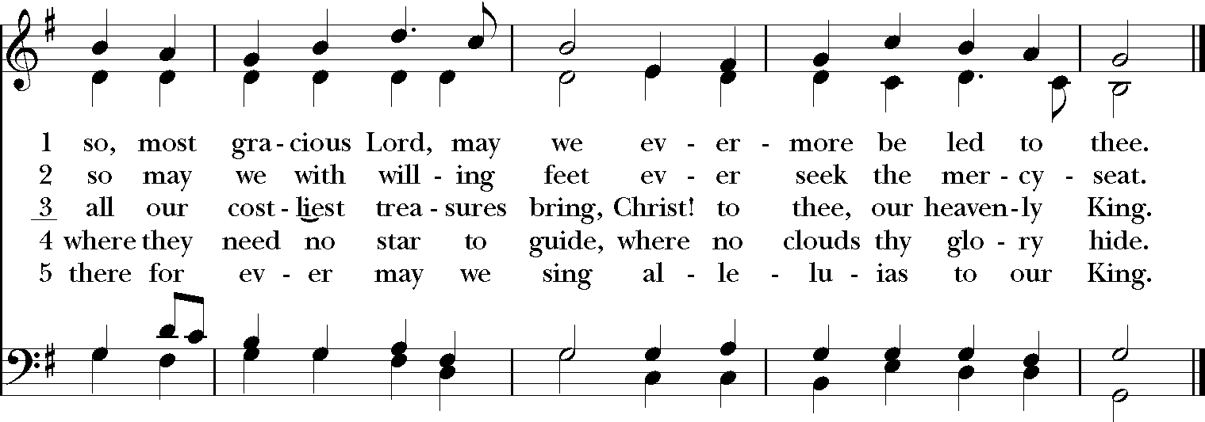

Gospel Matthew 2:1-12

Priest The Holy Gospel of Our Lord Jesus Christ according to Matthew.
People Glory to you, Lord Christ.

In the time of King Herod, after Jesus was born in Bethlehem of Judea, wise men from the East came to Jerusalem, asking, “Where is the child who has been born king of the Jews? For we observed his star at its rising, and have come to pay him homage.” When King Herod heard this, he was frightened, and all Jerusalem with him; and calling together all the chief priests and scribes of the people, he inquired of them where the Messiah was to be born. They told him, “In Bethlehem of Judea; for so it has been written by the prophet:

‘And you, Bethlehem, in the land of Judah,
are by no means least among the rulers of Judah;
for from you shall come a ruler
who is to shepherd my people Israel.’”

Then Herod secretly called for the wise men and learned from them the exact time when the star had appeared. Then he sent them to Bethlehem, saying, "Go and search diligently for the child; and when you have found him, bring me word so that I may also go and pay him homage."

When they had heard the king, they set out; and there, ahead of them, went the star that they had seen at its rising, until it stopped over the place where the child was. When they saw that the star had stopped, they were overwhelmed with joy. On entering the house, they saw the child with Mary his mother; and they knelt down and paid him homage. Then, opening their treasure chests, they offered him gifts of gold, frankincense, and myrrh. And having been warned in a dream not to return to Herod, they left for their own country by another road.

Priest The Gospel of the Lord.
People Praise to you, Lord Christ.
The people are seated.

Sermon The Rt. Rev. Robert Ihloff

A moment of silence is kept after the sermon.

The people stand as they are able.

Nicene Creed

Celebrant and People
We believe in one God,
the Father, the Almighty, maker of heaven and earth,
of all that is, seen and unseen.
We believe in one Lord, Jesus Christ,
the only Son of God, eternally begotten of the Father,
God from God, Light from Light,
true God from true God, begotten, not made,
of one Being with the Father.
Through him all things were made.
For us and for our salvation
he came down from heaven:
by the power of the Holy Spirit
he became incarnate from the Virgin Mary,
and was made man.
For our sake he was crucified under Pontius Pilate;
he suffered death and was buried.
On the third day he rose again
in accordance with the Scriptures;
he ascended into heaven
and is seated at the right hand of the Father.
He will come again in glory to judge the living and the dead,
and his kingdom will have no end.
We believe in the Holy Spirit, the Lord, the giver of life,
who proceeds from the Father and the Son.
With the Father and the Son he is worshiped and glorified.
He has spoken through the Prophets.
We believe in one holy catholic and apostolic Church.
We acknowledge one baptism for the forgiveness of sins.
We look for the resurrection of the dead,
and the life of the world to come. Amen.

Prayers of the People layanglicana.org

Leader Let us pray in the glorious light of Christ.

Lord, who sent your son to guide us, your people, and who sent a star to guide the Wise Men to his worship, send us now, we pray, to guide our Church and to inspire our leaders, especially Michael, our Presiding Bishop, and Eugene and Robert, our bishops.
Lighten our darkness and guide us to you, O Lord; in your mercy hear our prayer.

Lord, let the star of your justice always shine in our hearts, that we may give as our treasure all that we are to your service. Trusting in your word as a lamp unto our feet, and a light unto our path, we go out into the darkness for others.
Lighten our darkness and guide us to you, O Lord; in your mercy hear our prayer.

We give thanks, O Lord, that you are present in our homes and in our lives; we seek your continuous guidance. We pray for our neighbors, especially those in trouble or in need or experiencing illness, especially.... Help us to offer light to those in need, and graciously accept when light is offered to us in turn.
Lighten our darkness and guide us to you, O Lord; in your mercy hear our prayer.

We pray for all who are coming to the end of their journey here on earth and pray that they may come into your presence and kingdom. We pray for all those who have come before you, especially... May they now rejoice in the fullness of life eternal.
Lighten our darkness and guide us to you, O Lord; in your mercy hear our prayer.
Celebrant Holy God, you gather the whole universe into your radiant presence and continually reveal your Son as our Savior. Bring healing to all wounds, make whole all that is broken, speak truth to all illusion, and shed light in every darkness, that all creation will see your glory and know your Christ. Amen.

Confession of Sin

Celebrant Let us confess our sins against God and our neighbor.

Celebrant and People
Most merciful God,
we confess that we have sinned against you
in thought, word, and deed,
by what we have done,
and by what we have left undone.
We have not loved you with our whole heart;
we have not loved our neighbors as ourselves.
We are truly sorry and we humbly repent.
For the sake of your Son Jesus Christ,
have mercy on us and forgive us;
that we may delight in your will,
and walk in your ways,
to the glory of your Name. Amen.
Celebrant Almighty God have mercy on you, forgive you all your sins through our Lord Jesus Christ,
strengthen you in all goodness, and by the power of the Holy Spirit keep you in eternal life. Amen.

Peace

Celebrant The peace of the Lord be always with you.
People And also with you.

The Peace is then exchanged and the people are seated.

Welcome & Announcements

Birthdays & Anniversaries

Holy Communion

The people remain seated while offertory music is sung, and bread and wine are brought to the altar. An offering of gifts is collected, and along with the bread and wine, they are presented to God as thanksgiving for the blessings poured out onto us. Our gifts: bread, wine, music and money, become sacramental in God’s economy.

Hymn We three kings of Orient are Three Kings of Orient

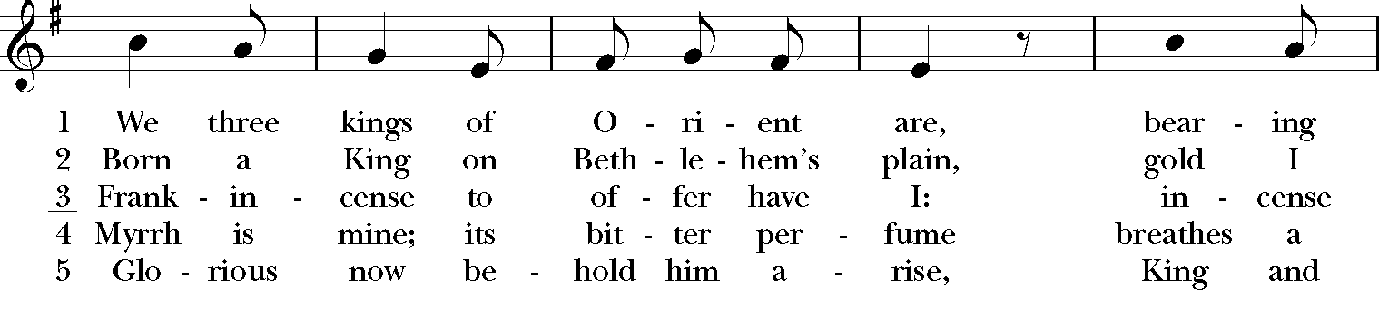
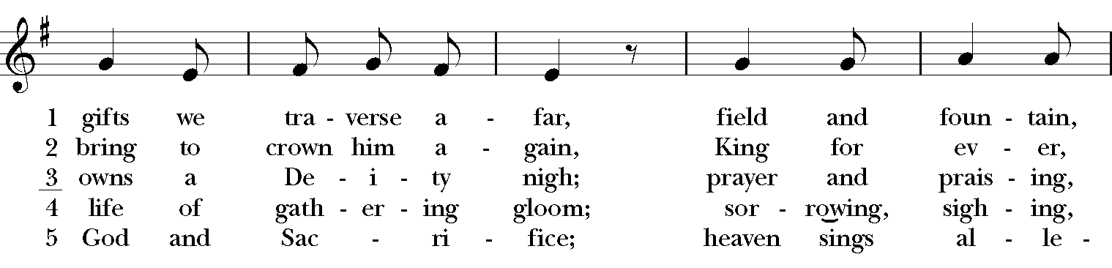
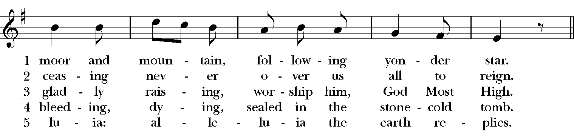
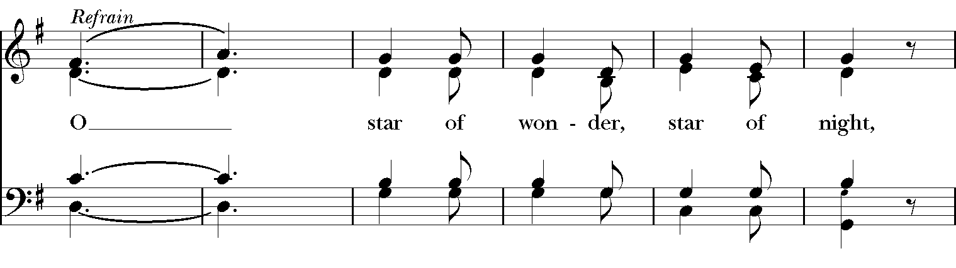
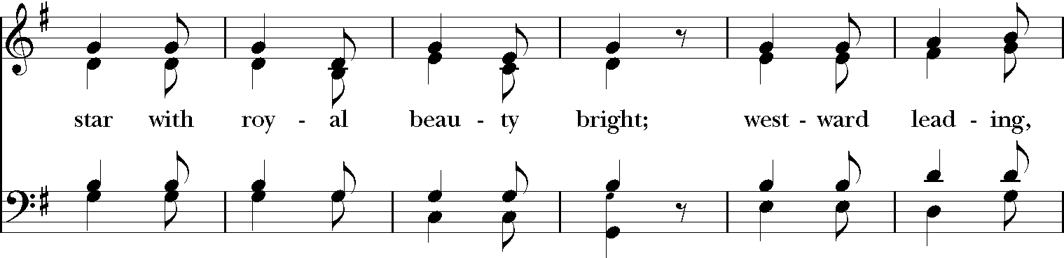
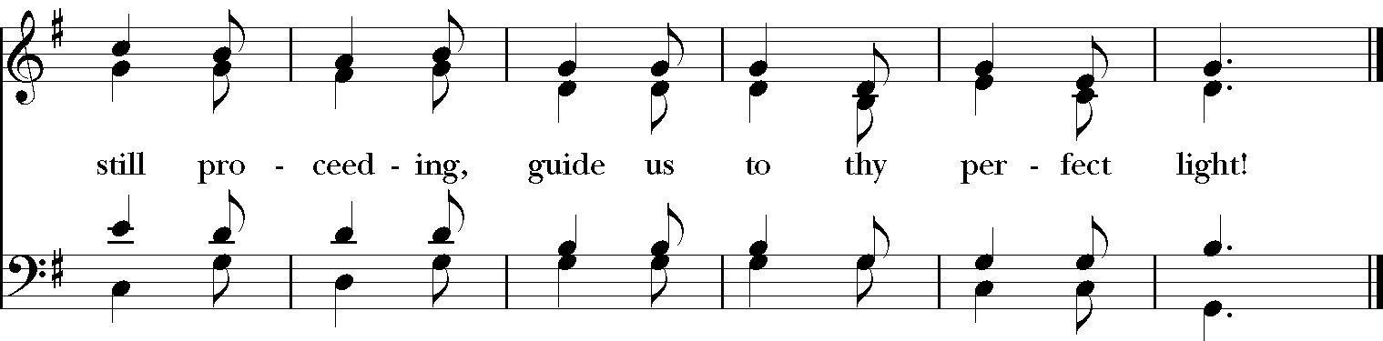

The people stand as able when directed by clergy.

Great Thanksgiving Eucharistic Prayer C

Celebrant The Lord be with you.
People And also with you.
Celebrant Lift up your hearts.
People We lift them to the Lord.
Celebrant Let us give thanks to the Lord our God.
People It is right to give him thanks and praise.

God of all power, Ruler of the Universe, you are worthy of glory and praise.
Glory to you for ever and ever.
At your command all things came to be: the vast expanse of interstellar space, galaxies, suns, the planets in their courses, and this fragile earth, our island home.
By your will they were created and have their being.
From the primal elements you brought forth the human race, and blessed us with memory, reason, and skill. You made us the rulers of creation. But we turned against you, and betrayed your trust; and we turned against one another.
Have mercy, Lord, for we are sinners in your sight.

Again and again, you called us to return. Through prophets and sages you revealed your righteous Law. And in the fullness of time you sent your only Son, born of a woman, to fulfill your Law, to open for us the way of freedom and peace.
By his blood, he reconciled us.
By his wounds, we are healed.
And therefore we praise you, joining with the heavenly chorus, with prophets, apostles, and martyrs, and with all those in every generation who have looked to you in hope, to proclaim with them your glory, in their unending hymn:

Sanctus Franz Schubert

The Celebrant continues
And so, Father, we who have been redeemed by him, and made a new people by water and the Spirit, now bring before you these gifts. Sanctify them by your Holy Spirit to be the Body and Blood of Jesus Christ our Lord.

On the night he was betrayed he took bread, said the blessing, broke the bread, and gave it to his friends, and said, "Take, eat: This is my Body, which is given for you. Do this for the remembrance of me."

After supper, he took the cup of wine, gave thanks, and said, "Drink this, all of you: This is my Blood of the new Covenant, which is shed for you and for many for the forgiveness of sins. Whenever you drink it, do this for the remembrance of me."

Remembering now his work of redemption, and offering to you this sacrifice of thanksgiving,
We celebrate his death and resurrection, as we await the day of his coming.

Lord God of our Fathers and Mothers: God of Abraham and Sarah, Isaac and Rebecca, and Jacob and Leah and Rachel; God and Father of our Lord Jesus Christ: Open our eyes to see your hand at work in the world about us. Deliver us from the presumption of coming to this Table for solace only, and not for strength; for pardon only, and not for renewal. Let the grace of this Holy Communion make us one body, one spirit in Christ, that we may worthily serve the world in his name.
Risen Lord, be known to us in the breaking of the Bread.

Accept these prayers and praises, O God, through Jesus Christ our great High Priest, to whom, with you and the Holy Spirit, your Church gives honor, glory, and worship, from generation to generation. Amen.

Lord’s Prayer

Celebrant And now, as our Savior Christ has taught us, we are bold to say,

Celebrant and People
Our Father, who art in heaven,
hallowed be thy Name,
thy kingdom come, thy will be done,
on earth as it is in heaven.
Give us this day our daily bread.
And forgive us our trespasses,
as we forgive those who trespass against us.
And lead us not into temptation,
but deliver us from evil.
For thine is the kingdom,
and the power, and the glory,
for ever and ever. Amen.

Breaking of the Bread

Celebrant God of promise, you have prepared a banquet for us.
People Happy are those who are called to the Supper of the Lamb.

The Celebrant breaks the consecrated bread.

Fraction Anthem F. Schubert

Invitation to Communion

Celebrant The Gifts of God for the People of God. Take them in remembrance that Christ lived and died for you and feed on him in your hearts with thanksgiving.

The people are seated.

Gluten-free wafers are available for communion. Indicate your wish for a gluten-free wafer by first extending your hands palms down when at the communion rail. The square wafers are kept in a separate holder and you are invited to take one from this holder.

If you have a child who is participating in the Epiphany Pageant, please escort them to the Fellowship Hall in the Formation Building to get ready after communion is taken.

Carol Away in a manger Normandy Traditional arr. Reginald Jacques

Away in a manger, no crib for a bed, the little Lord Jesus laid down his sweet head.
The stars in the bright sky looked down where he lay. The little Lord Jesus asleep on the hay.
The cattle are lowing, the baby awakes, but little Lord Jesus no crying he makes.
I love thee, Lord Jesus! Look down from the sky, and stay by my side until morning is nigh.
Be near me, Lord Jesus; I ask thee to stay close by me for ever, and love me, I pray.
Bless all the dear children in thy tender care, and fit us for heaven, to live with thee there.

Hymn What star is this, with beams so bright Puer nobis

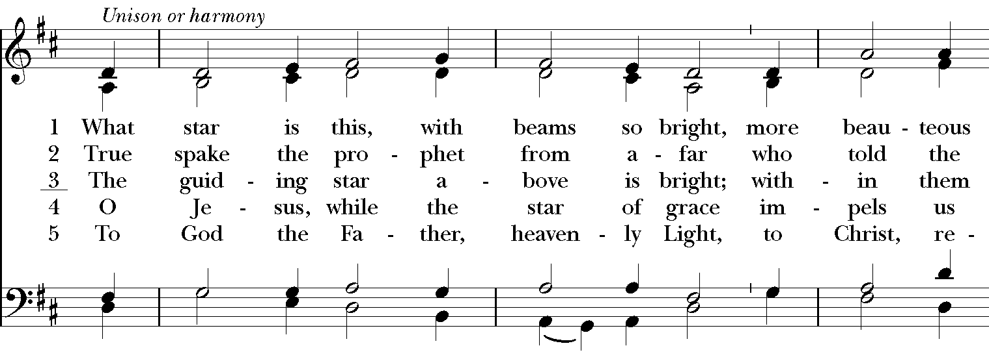
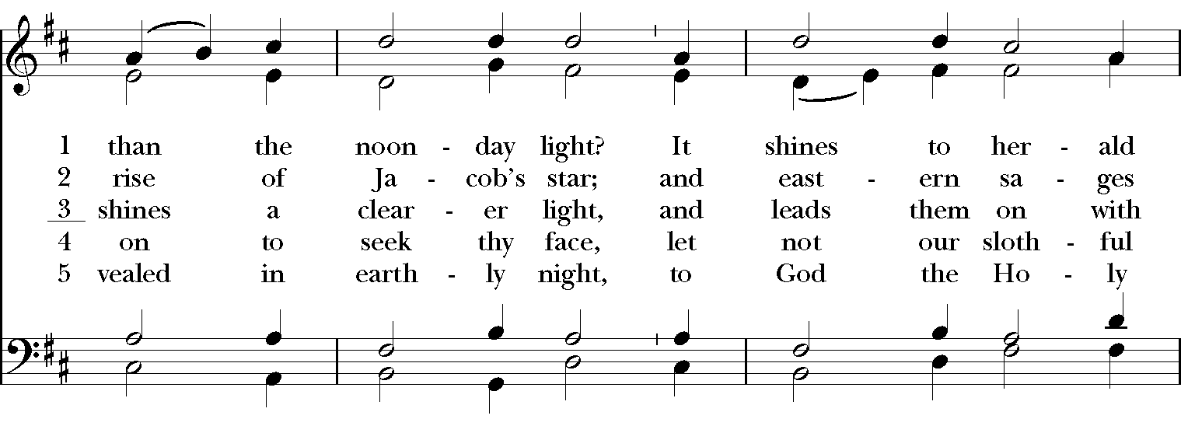
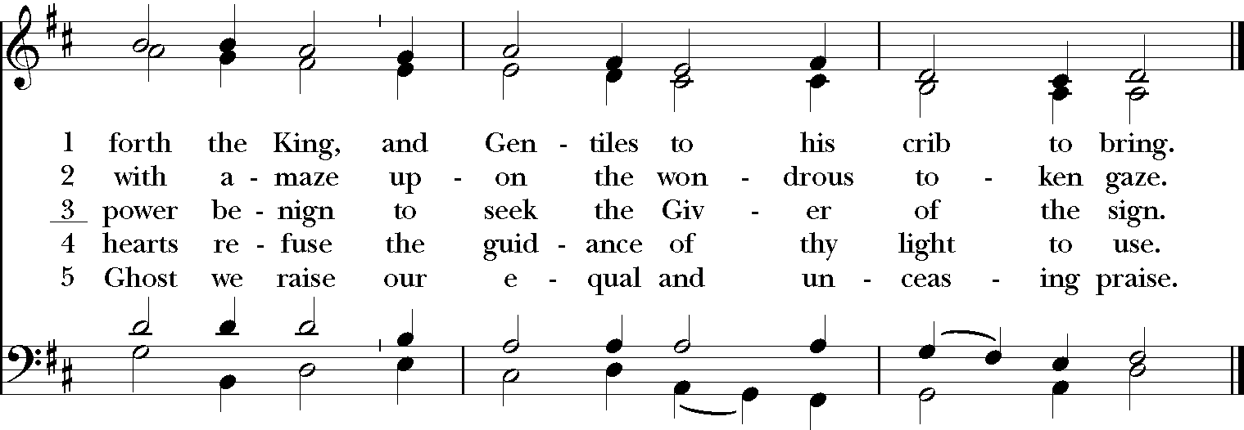

After communion, the people stand as able.

Sending Forth of Eucharistic Visitors

On most Sundays, we send out Eucharistic visitors to deliver the sacraments to those who cannot be with us. This is the prayer we use to send them on their way.

Celebrant In the name of this congregation I send you forth bearing these holy gifts, to N. that they may share with us in the sacrament of our Savior Jesus Christ.
People We who are many are One Body, because we all share one Bread, and one Cup. Amen.

Postcommunion Prayer

Celebrant Let us pray.

Celebrant and People
Eternal God, heavenly Father,
you have graciously accepted us as living members
of your Son our Savior Jesus Christ,
and you have fed us with spiritual food
in the Sacrament of his Body and Blood.
Send us now into the world in peace,
and grant us strength and courage
to love and serve you
with gladness and singleness of heart;
through Christ our Lord. Amen.

Blessing

And now, may Almighty God, who led the Wise Men by the shining of a star to find the Christ, the Light from Light, lead you also in your pilgrimage to find the Lord. Amen.

Hymn How bright appears the Morning Star Wie schön leuchtet

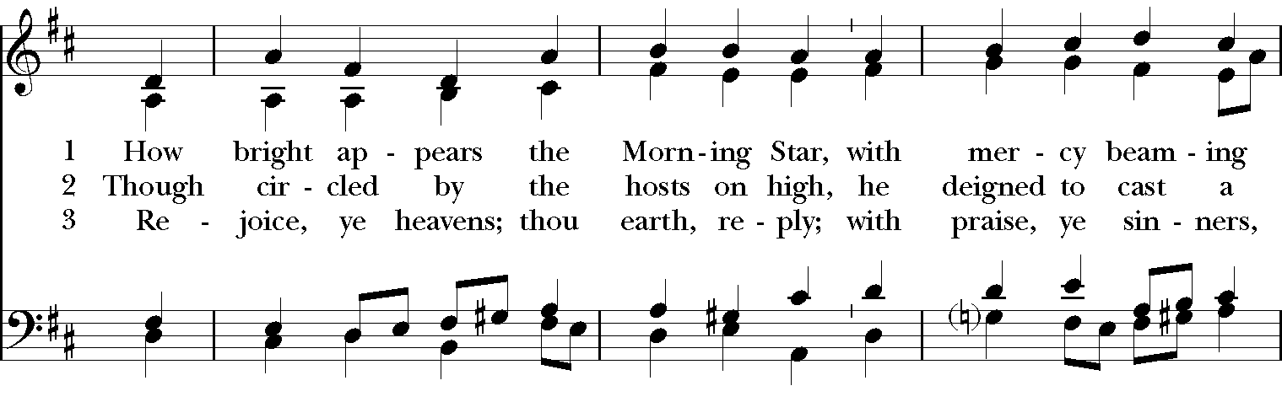
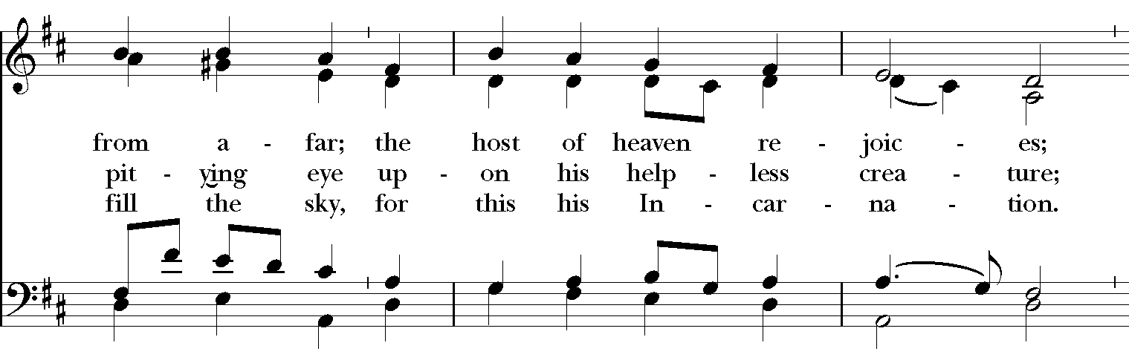
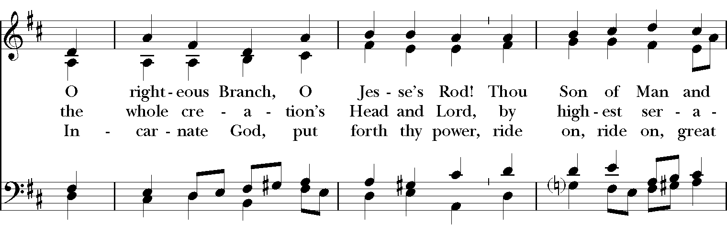
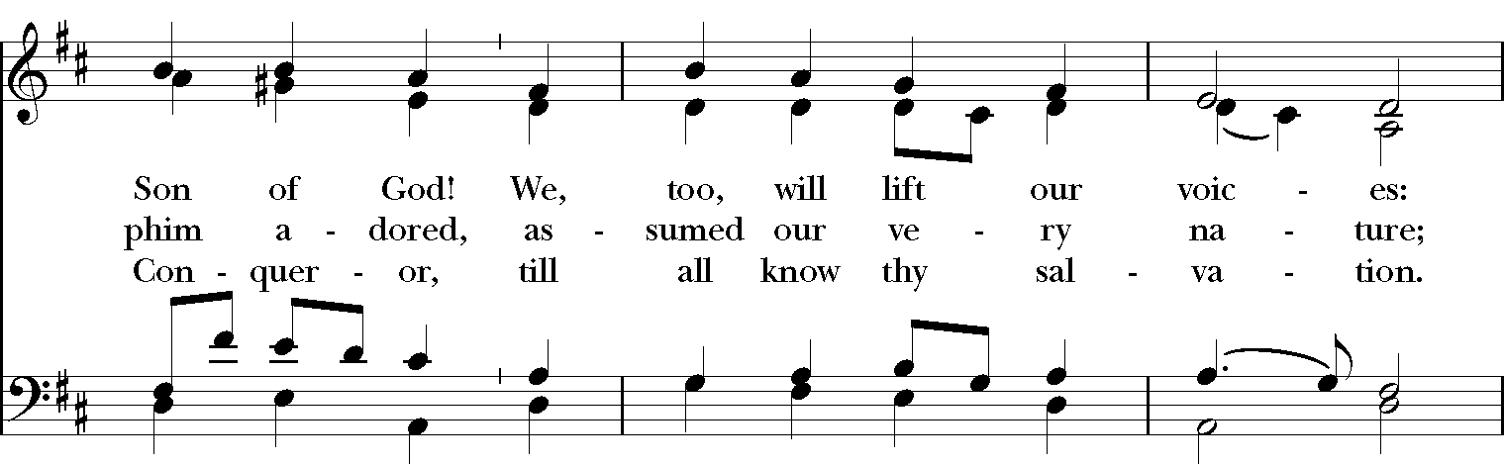
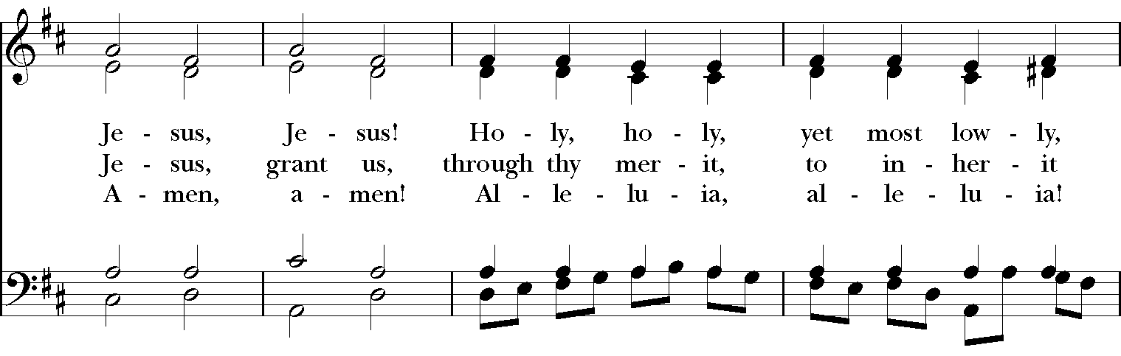
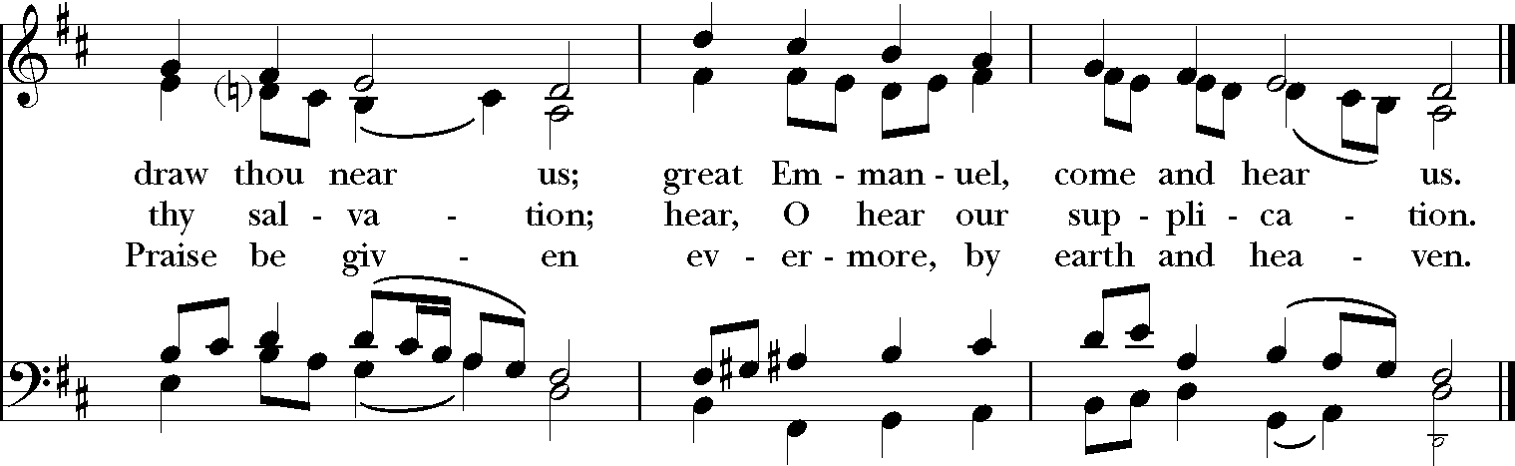

Dismissal

Celebrant Alleluia. Alleluia. Let us go forth in the name of Christ.
People Thanks be to God. Alleluia. Alleluia.

Postlude
You are welcome to stay for the Postlude.
Should you need to leave, please do so quietly and respectfully.

Please join us for our annual Children’s Epiphany Pageant in the Parish Hall
after the 9 a.m. service this morning.

In This Service

Music: Jim Douglas
Members of the Chancel Choir & Motet Ensemble
Eucharistic Ministers @ 9: Jim Barnett, Kim Coble
Lectors @ 9: Stacy Canuel, Barbara Marder
Acolytes @ 9: Joseph Jackson, Zacca Jackson, Allen Mayer, Sarah Mayer, Hannah Ruegg
Children's Chapel: Emily Delsordo, Ernie Tucker, Ella Tomko
Eucharistic Ministers @ 11:15: Janis Brewer, Jim Reising
Lectors @ 11:15: Robert Thomas, Jim Weekley
Acolytes @ 11:15: Connor Feldmann, Grace Feldmann, Wes Reising, Henry Macmillan
Altar Guild: Elizabeth Parker, Susan Roberts, Lyn Sloan, Betsy Dobbs
Decorations: St. Margaret’s Flower Guild
Coffeehour Hosts: Susan Roberts, Jim Barnett, Holly and Brian Williams, Katy Strother

Welcome Bishop Ihloff

We welcome Bishop Robert Ihloff to St. Margaret's this morning. The Rt. Rev. Ihloff recently re-joined the staff of the Episcopal Diocese of Maryland to serve as assisting bishop to the Rt. Rev. Eugene Taylor Sutton this month. He will serve as second bishop in an appropriate ecclesiastical capacity and as staff liaison to the Commission on Ministry.

Born and raised in central Connecticut, Bishop Ihloff was ordained a deacon in 1967 and priest in 1968. Before becoming Bishop of Maryland, he served parishes in Connecticut, Massachusetts and New Jersey.

Bishop Ihloff earned a B.A. with departmental honors in history from Ursinus College in 1964; an M.A. in modern European history from Central Connecticut University in 1973; an M.Div. from Episcopal Theological School (later Episcopal Divinity School) in 1967; a D.Min from Episcopal Divinity School in 1985. His thesis/project was in the area Group Spiritual Direction. He is the recipient of three honorary Doctor of Divinity degrees.

Bishop Ihloff and his wife Nancy have two married children and six grandchildren. He is a voracious reader and an opera lover. A life-long gardener, he has, over the years, cultivated more than 150 varieties of 19th century English roses.

