***1601 Pleasant Plains Rd, Annapolis, MD 21409***

***410-974-0200 www.st-margarets.org***

***Emergency Pastoral Number: 443-837-5463***

**The Twentieth Sunday after Pentecost**

**Sunday, October 25, 2020**

**9:00 a.m. & 11:15 a.m.**

**Holy Eucharist Rite II**

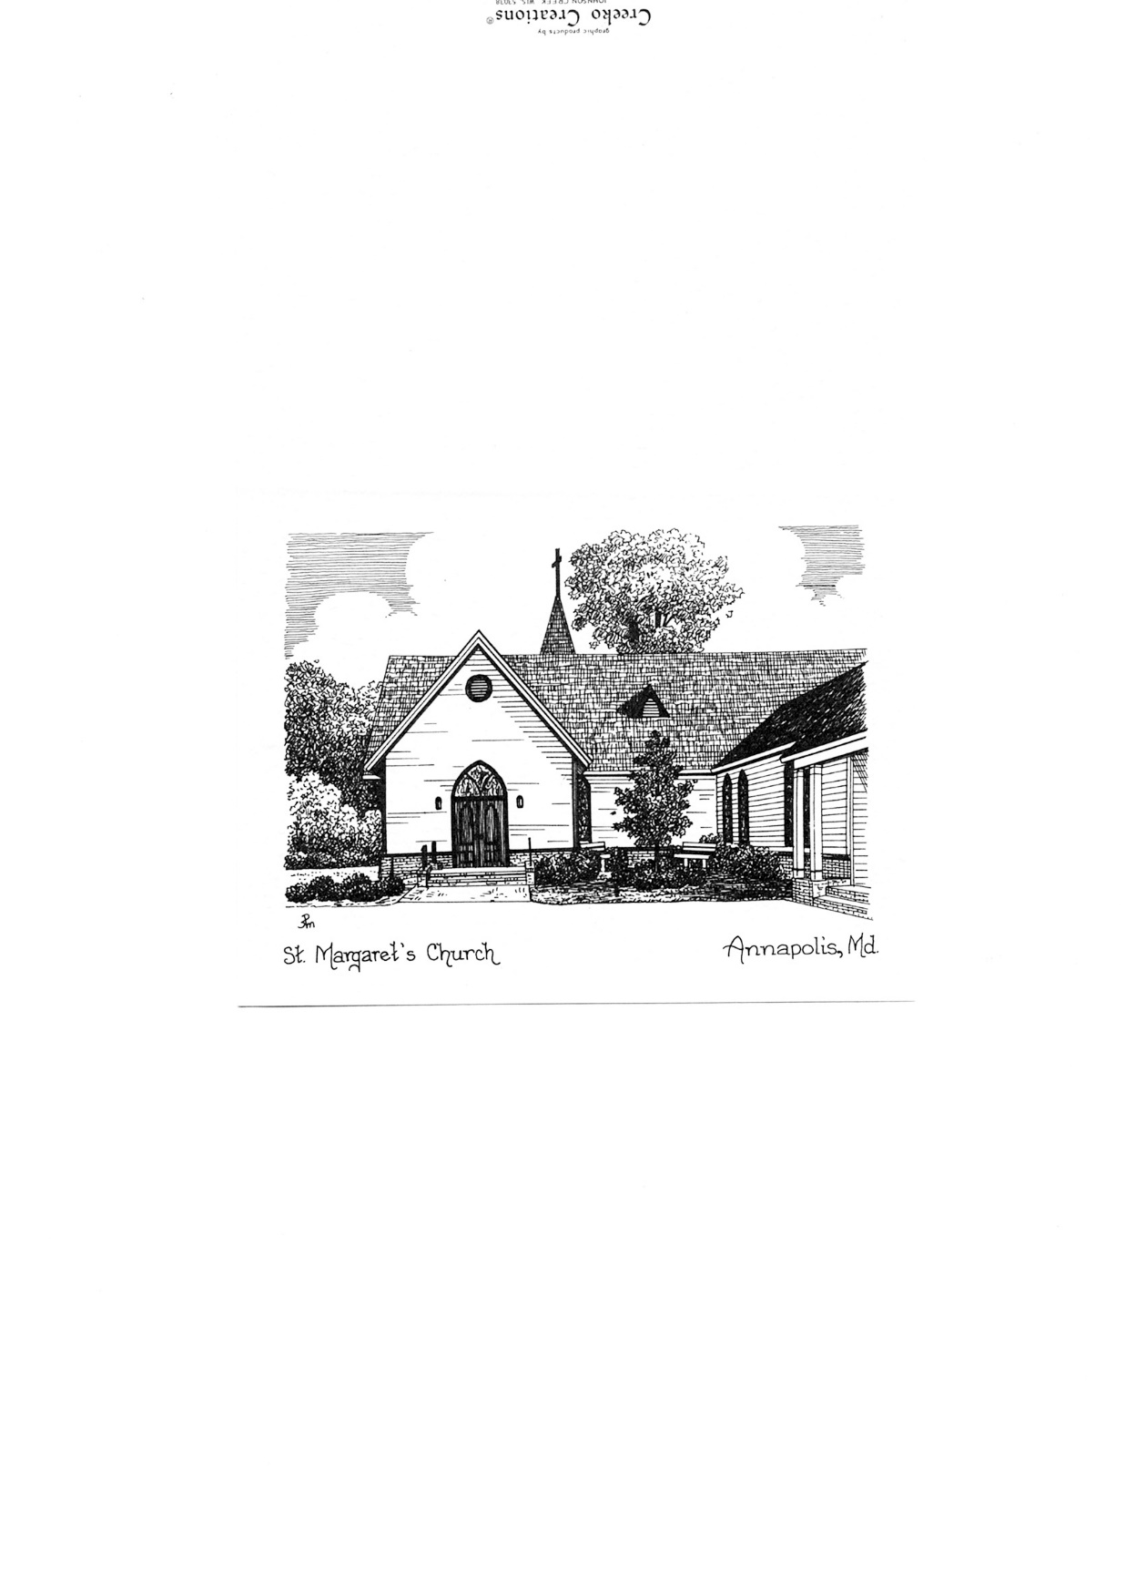

**Preacher: The Rev. Peter Mayer, Rector**

**Celebrant: The Rev. Patti Sachs, Assoc. Rector**

**Organist: Jim Douglas, Director of Music**

**Cantor: Trish Schilling**

**Altar Guild: Jeanne Nardi, Jan Little, Mary Lesster, Kim Morrow**

**Altar Flowers: Mary Kirkeby**

**Welcome**

**Prelude** Be Thou My Vision *Traditional arr. Daniel Burton*

Kristen Berthelotte, *harp*

*The People stand as able.*

**Hymn *(sung by the cantor)*** O God, our help in ages past *St. Anne*

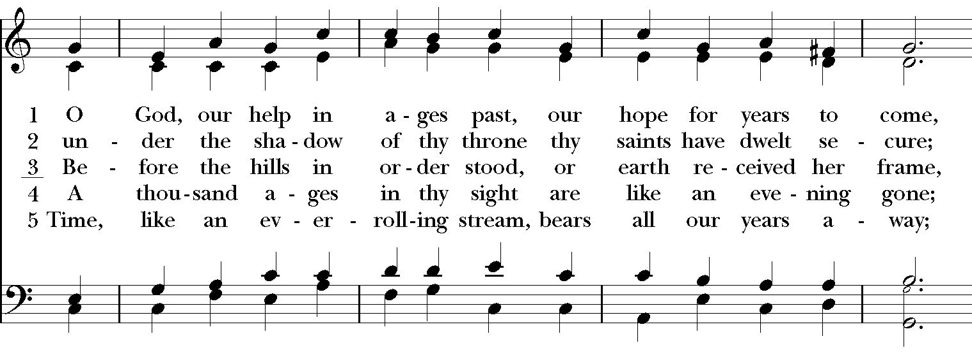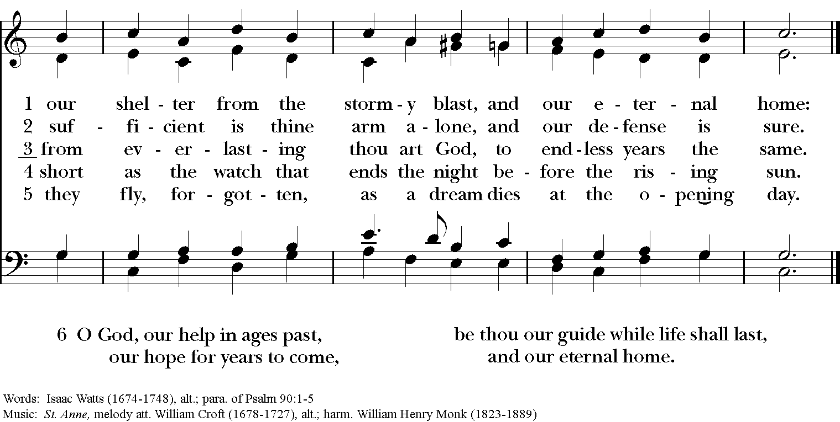

*The People remain standing as they are able.*

**Opening Acclamation**

*Celebrant* Blessed be God: Father, Son, and Holy Spirit.

*People*        **And blessed be God’s kingdom, now and for ever. Amen.**

**Collect for Purity**

*Celebrant* Almighty God, to you all hearts are open, all desires known, and from you no secrets are hid:

Cleanse the thoughts of our hearts by the inspiration of your Holy Spirit, that we may perfectly love you, and

worthily magnify your holy Name; through Christ our Lord. **Amen.**

**Kyrie Eleison**

*Celebrant* Lord, have mercy.

*People***Christ, have mercy.**

*Celebrant* Lord, have mercy.

**Collect of the Day**

*Celebrant* The Lord be with you*.*

*People* **And also with you.**

*Celebrant* Let us pray.

Almighty and everlasting God, increase in us the gifts of faith, hope, and charity; and, that we may obtain what you promise, make us love what you command; through Jesus Christ our Lord, who lives and reigns with you and the Holy Spirit, one God, for ever and ever. **Amen.**

*The People are seated.*

**First Lesson** Deuteronomy 34:1-12

A lesson from the book of Deuteronomy.

Moses went up from the plains of Moab to Mount Nebo, to the top of Pisgah, which is opposite Jericho, and the Lord showed him the whole land: Gilead as far as Dan, all Naphtali, the land of Ephraim and Manasseh, all the land of Judah as far as the Western Sea, the Negeb, and the Plain—that is, the valley of Jericho, the city of palm trees—as far as Zoar. The Lord said to him, “This is the land of which I swore to Abraham, to Isaac, and to Jacob, saying, ‘I will give it to your descendants’; I have let you see it with your eyes, but you shall not cross over there.” Then Moses, the servant of the Lord, died there in the land of Moab, at the Lord’s command. He was buried in a valley in the land of Moab, opposite Beth-peor, but no one knows his burial place to this day. Moses was one hundred twenty years old when he died; his sight was unimpaired and his vigor had not abated. The Israelites wept for Moses in the plains of Moab thirty days; then the period of mourning for Moses was ended.

Joshua son of Nun was full of the spirit of wisdom, because Moses had laid his hands on him; and the Israelites obeyed him, doing as the Lord had commanded Moses.

Never since has there arisen a prophet in Israel like Moses, whom the Lord knew face to face. He was unequaled for all the signs and wonders that the Lord sent him to perform in the land of Egypt, against Pharaoh and all his servants and his entire land, and for all the mighty deeds and all the terrifying displays of power that Moses performed in the sight of all Israel.

*Reader* The Word of the Lord.

*People* **Thanks be to God.**

**Psalm 90:1-16, 13-17 *(read by the Lector)***

1 Lord, you have been our refuge *

from one generation to another.

2 Before the mountains were brought forth,

or the land and the earth were born, *

from age to age you are God.

3 You turn us back to the dust and say, *

"Go back, O child of earth."

4 For a thousand years in your sight are like yesterday when it is past *

and like a watch in the night.

5 You sweep us away like a dream; *

we fade away suddenly like the grass.

6 In the morning it is green and flourishes; *

in the evening it is dried up and withered.

13 Return, O Lord; how long will you tarry? *

be gracious to your servants.

14 Satisfy us by your loving-kindness in the morning; *

so shall we rejoice and be glad all the days of our life.

15 Make us glad by the measure of the days that you afflicted us *

and the years in which we suffered adversity.

16 Show your servants your works *

and your splendor to their children.

17 May the graciousness of the Lord our God be upon us; *

prosper the work of our hands;

prosper our handiwork.

*The People stand as they are able.*

**Hymn *(sung by the cantor)*** Be thou my vision *Slane*

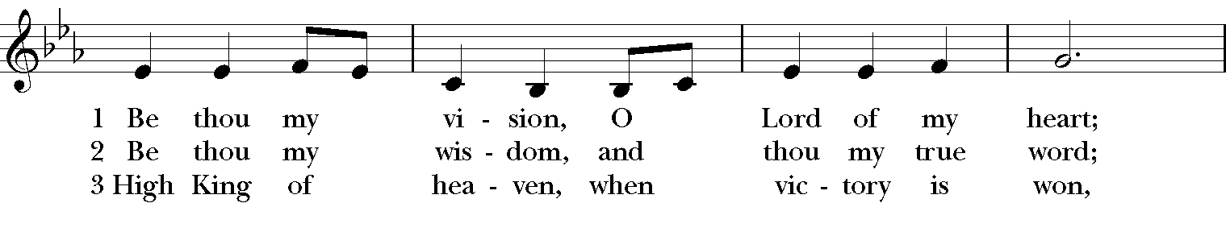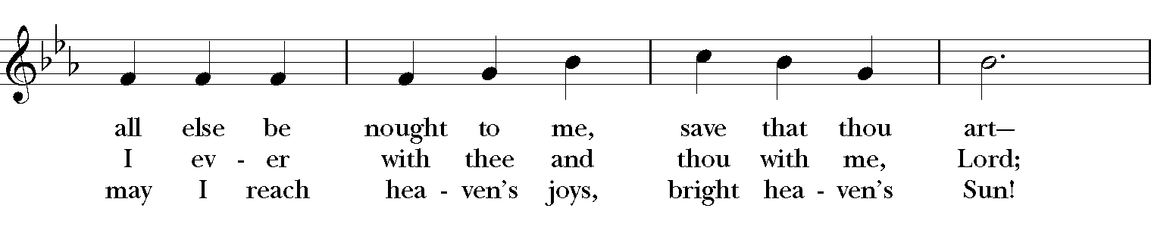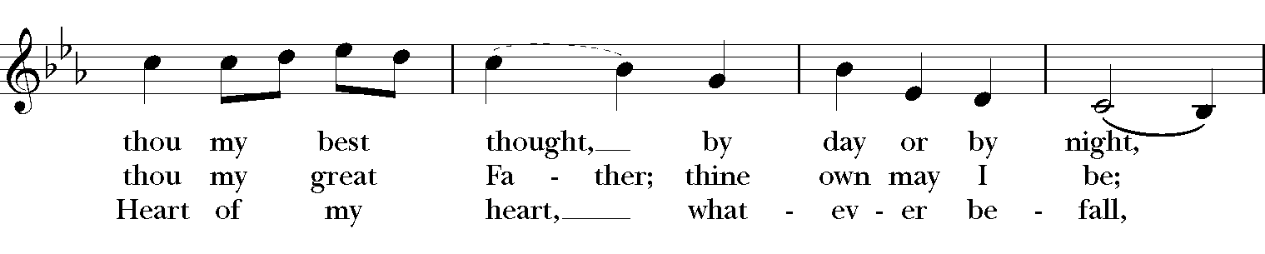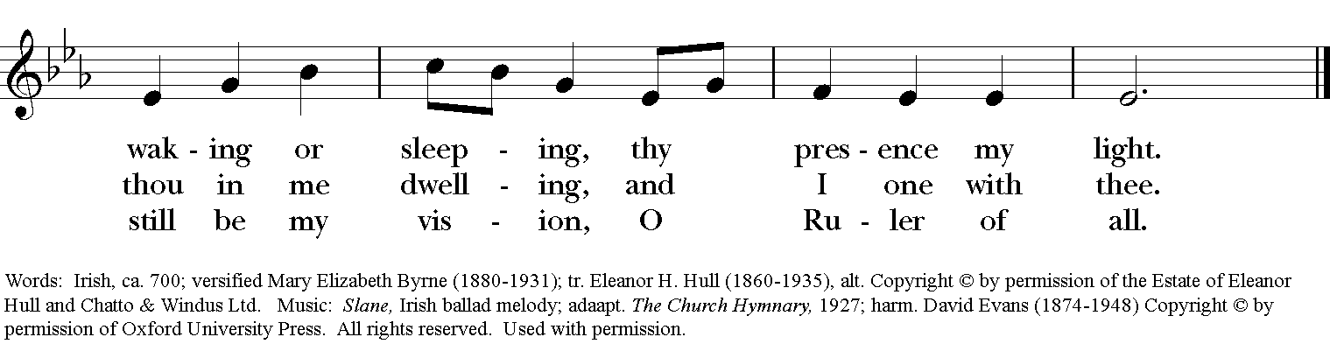

**Gospel** Matthew 22:34-46

*Priest* The Holy Gospel of Our Lord Jesus Christ according to Matthew.

*People* **Glory to you, Lord Christ.**

When the Pharisees heard that Jesus had silenced the Sadducees, they gathered together, and one of them, a lawyer, asked him a question to test him. “Teacher, which commandment in the law is the greatest?” He said to him, “’You shall love the Lord your God with all your heart, and with all your soul, and with all your mind.’ This is the greatest and first commandment. And a second is like it: ‘You shall love your neighbor as yourself.’ On these two commandments hang all the law and the prophets.”

Now while the Pharisees were gathered together, Jesus asked them this question: “What do you think of the Messiah? Whose son is he?” They said to him, “The son of David.” He said to them, “How is it then that David by the Spirit calls him Lord, saying,

‘The Lord said to my Lord,

“Sit at my right hand,

until I put your enemies under your feet”’?

If David thus calls him Lord, how can he be his son?” No one was able to give him an answer, nor from that day did anyone dare to ask him any more questions.

*Priest* The Gospel of the Lord.  
*People* **Praise to you, Lord Christ.**

*The People are seated.*

**Sermon** The Rev. Peter W. Mayer

*The People stand as they are able.*

**Nicene Creed**

***The Celebrant recites for the People***

We believe in one God, the Father, the Almighty, maker of heaven and earth,of all that is, seen and unseen.

We believe in one Lord, Jesus Christ, the only Son of God, eternally begotten of the Father, God from God, Light from Light, true God from true God, begotten, not made, of one Being with the Father. Through him all things were made. For us and for our salvation he came down from heaven: by the power of the Holy Spirit he became incarnate from the Virgin Mary, and was made man. For our sake he was crucified under Pontius Pilate; he suffered death and was buried. On the third day he rose again in accordance with the Scriptures; he ascended into heaven and is seated at the right hand of the Father. He will come again in glory to judge the living and the dead and his kingdom will have no end.

We believe in the Holy Spirit, the Lord, the giver of life, who proceeds from the Father and the Son. With the Father and the Son he is worshiped and glorified. He has spoken through the Prophets. We believe in one holy catholic and apostolic Church. We acknowledge one baptism for the forgiveness of sins. We look for the resurrection of the dead and the life of the world to come. **Amen.**

**Prayers of the People**  Form IV

Let us pray for the Church and for the world.

Grant, Almighty God, that all who confess your Name may be united in your truth, live together in your love, and reveal your glory in the world.

Lord, in your mercy

**Hear our prayer.**

Guide the people of this land, and of all the nations, in the ways of justice and peace; that we may honor one another and serve the common good.

Lord, in your mercy

**Hear our prayer.**

Give us all a reverence for the earth as your own creation, that we may use its resources rightly in the service of others and to your honor and glory.

Lord, in your mercy

**Hear our prayer.**

Bless all whose lives are closely linked with ours, and grant that we may serve Christ in them, and love one another as he loves us.

Lord, in your mercy

**Hear our prayer.**

Comfort and heal all those who suffer in body, mind, or spirit; give them courage and hope in their troubles, and bring them the joy of your salvation.

Lord, in your mercy

**Hear our prayer.**

We commend to your mercy all who have died, that your will for them may be fulfilled; and we pray that we may share with all your saints in your eternal kingdom.

Lord, in your mercy

**Hear our prayer.**

O Lord our God, accept the fervent prayers of your people; in the multitude of your mercies, look with compassion upon us and all who turn to you for help; for you are gracious, O lover of souls, and to you we give glory, Father, Son, and Holy Spirit, now and for ever. **Amen.**

**Stewardship Prayer**

Creator God, life is your gift to us. Through Baptism you invite each of us to share the gift of life in service to others. Hear our prayers as we strive to be good stewards. Open the minds and hearts of the people of our parish so that we may accept your challenge to use all our gifts in service to You and in communion with one another to build your Kingdom on earth. Make us keenly aware of all the blessings of our rich lives. Help us to be good stewards of our time by putting prayer first in our lives. Help us to be good stewards of our talent by putting ourselves at the service of each other. Help us to be good stewards of our treasure by sharing our financial means to build up our Church and aid those in need. Make your love the foundation of our lives. May our love for you express itself through our eagerness to use our time, our talent and our treasure to serve You, your Church and one another. **Amen.**

**Confession**

*Celebrant* Let us confess our sins to God and our neighbors.

***The Celebrant recites for the People***

Most merciful God, we confess that we have sinned against you in thought, word, and deed, by what we have done, and by what we have left undone. We have not loved you with our whole heart; we have not loved our neighbors as ourselves. We are truly sorry and we humbly repent. For the sake of your Son Jesus Christ, have mercy on us and forgive us; that we may delight in your will, and walk in your ways, to the glory of your Name. **Amen.**

**Absolution**

*Celebrant* Almighty God have mercy on you, forgive you all your sins through our Lord Jesus Christ, strengthen you in all goodness, and by the power of the Holy Spirit keep you in eternal life. **Amen.**

**Peace**

*Celebrant*    The peace of the Lord be always with you.

*People*          **And also with you.**

*Please be seated and respect physical distancing requirements.*

**Announcements**

**Holy Communion**

The People stand as able.

**Great Thanksgiving** Eucharistic Prayer B

*Celebrant*  The Lord be with you.

*People*  **And also with you.**

*Celebrant* Lift up your hearts.

*People* **We lift them to the Lord.**

*Celebrant* Let us give thanks to the Lord our God.

*People* **It is right to give God thanks and praise.**

It is right, and a good and joyful thing, always and everywhere to give thanks to you, Father Almighty, Creator of heaven and earth.

For by water and the Holy Spirit you have made us a new people in Jesus Christ our Lord, to show forth your glory in all the world.

Therefore we praise you, joining our voices with Angels and Archangels and with all the company of heaven, who for ever proclaim the glory of your Name:

***The Celebrant recites for the People***

Holy, Holy, Holy, Lord;God of power and might;Heaven and earth are full of your glory;

Hosanna in the highest. Blessed is he who comes in the name of the Lord. Hosanna in the highest.

We give thanks to you, O God, for the goodness and love which you have made known to us in creation; in the calling of Israel to be your people; in your Word spoken through the prophets; and above all in the Word made flesh, Jesus, your Son.

For in these last days you sent him to be incarnate from the Virgin Mary, to be the Savior and Redeemer of the world. In him, you have delivered us from evil, and made us worthy to stand before you. In him, you have brought us out of error into truth, out of sin into righteousness, out of death into life.

On the night before he died for us, our Lord Jesus Christ took bread; and when he had given thanks to you, he broke it, and gave it to his disciples, and said, "Take, eat: This is my Body, which is given for you. Do this for the remembrance of me."

After supper he took the cup of wine; and when he had given thanks, he gave it to them, and said, "Drink this, all of you: This is my Blood of the new Covenant, which is shed for you and for many for the forgiveness of sins. Whenever you drink it, do this for the remembrance of me."

Therefore, according to his command, O Father,

***The Celebrant recites for the People***

We remember his death,  
We proclaim his resurrection,  
We await his coming in glory;

And we offer our sacrifice of praise and thanksgiving to you, O Lord of all; presenting to you, from your creation, this bread and this wine.

We pray you, gracious God, to send your Holy Spirit upon these gifts that they may be the Sacrament of the Body of Christ and his Blood of the new Covenant. Unite us to your Son in his sacrifice, that we may be acceptable through him, being sanctified by the Holy Spirit.

In the fullness of time, put all things in subjection under your Christ, and bring us to that heavenly country where, with Mary, Margaret, and all your saints, we may enter the everlasting heritage of your sons and daughters; through Jesus Christ our Lord, the firstborn of all creation, the head of the Church, and the author of our salvation.

By him, and with him, and in him, in the unity of the Holy Spirit all honor and glory is yours, Almighty Father, now and for ever**. Amen.**

### Lord’s Prayer

*Celebrant* And now, as our Savior Christ has taught us, we are bold to say,

*Celebrant and People*

**Our Father, who art in heaven,**

**hallowed be thy Name,**

**thy kingdom come, thy will be done,**

**on earth as it is in heaven.**

**Give us this day our daily bread.**

**And forgive us our trespasses,**

**as we forgive those**

**who trespass against us.**

**And lead us not into temptation,**

**but deliver us from evil.**

**For thine is the kingdom,**

**and the power, and the glory,**

**for ever and ever. Amen.**

**Breaking of the Bread**

*Celebrant* God of promise, you have prepared a banquet for us. Happy are those who are called to the supper of the Lamb.

**Invitation to Communion**

*Celebrant* The Gifts of God for the People of God. Take them in remembrance that Christ lived and died for you, and feed on him in your hearts by faith, with thanksgiving.

*The People are seated. Ushers will indicate when it is time to go to the front to receive. Gluten-free wafers are available for communion. Indicate your wish for a gluten-free wafer by first extending your hands palms down. The square wafers are kept in a separate holder and you are invited to take one from this holder. Wine will not be used at this time due to Covid guidelines.*

**Communion Music** Strengthen for service, Lord *Michael Sitton*

*Strengthen for service, Lord, the hands that holy things have taken;*

*let ears that now have heard thy songs to clamor never waken.*

*May tongues which “Holy” sang keep free from all deceiving;*

*the eyes which saw thy love be bright, thy blessed hope perceiving.*

*The feet that tread thy courts from light do not thou banish;*

*the bodies by thy Body fed with thy new life replenish.*

*After Communion, the People stand as able when directed.*

**Postcommunion Prayer**

*Celebrant* Let us pray.

***The Celebrant recites for the People***

Eternal God, heavenly Father, you have graciously accepted us as living members of your Son our Savior Jesus Christ, and you have fed us with spiritual food in the Sacrament of his Body and Blood. Send us now into the world in peace, and grant us strength and courage to love and serve you with gladness and singleness of heart; through Christ our Lord. **Amen.**

**Blessing**

The blessing of God Almighty, the Father, the Son, and the Holy Spirit, be among you, and remain with you always. **Amen.**

**Hymn *(sung by the cantor)*** How lovely is thy dwelling place *Brother James’ Air*

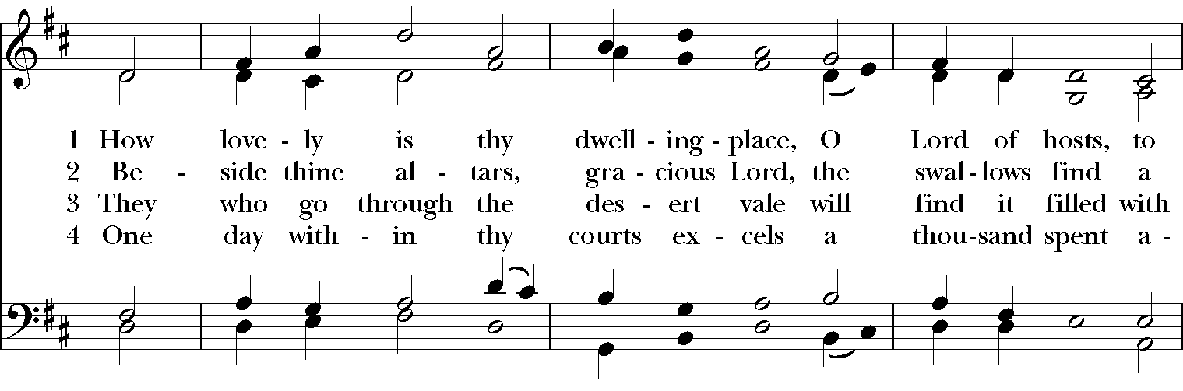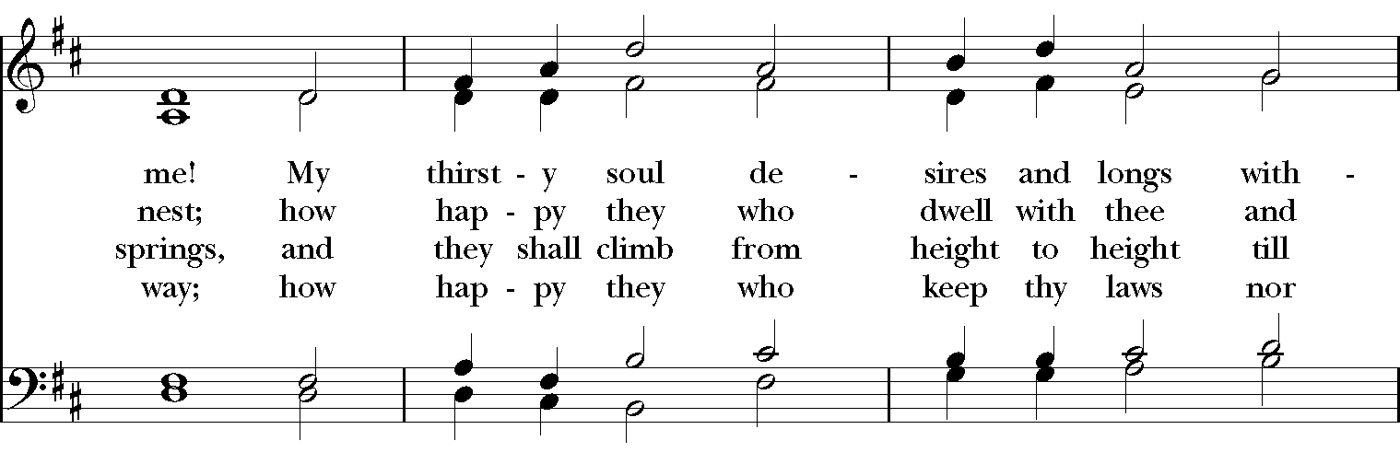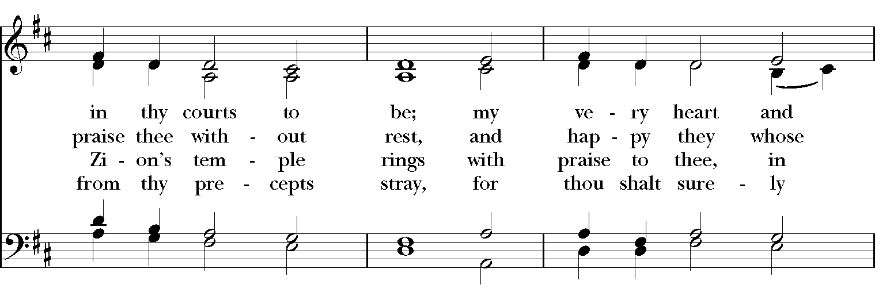

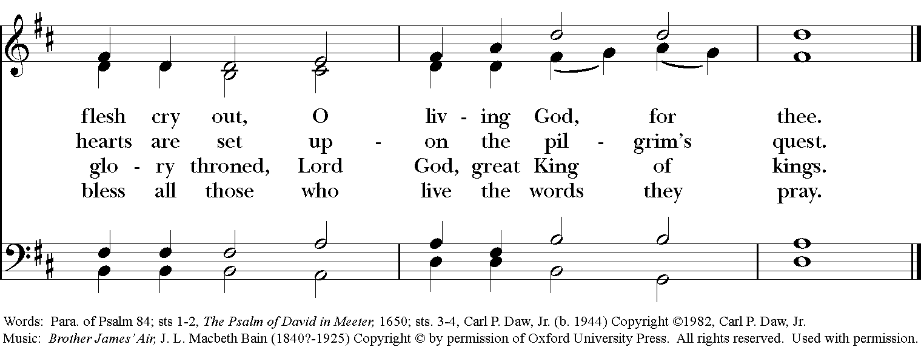

**Dismissal**

*Celebrant* Alleluia. Alleluia. Go in peace to love and serve the Lord.

*People* **Thanks be to God. Alleluia. Alleluia.**

**Postlude** *Brother James’ Air Traditional arr. D. Burton*

Kristen Berthelotte, *harp*

***Please be courteous and refrain from talking during the playing of the Postlude.***

*Please take this bulletin and announcements sheet with you.*

*Please leave the sanctuary right after the service so cleaning can begin.*

*There will be no coffee hour after the service.*

*The offertory plate is in the back of the sanctuary.*

***Stewardship Message***



Pledge today:

*in your Realm account

*on a pledge card (in the narthex or in the mail).

**It's so easy to make a pledge on Realm!**

**(1) Log into your Realm account at onrealm.org**

**(look for the Realm logo at the bottom of our website)**

**(2) Check your giving for this year.**

**(3) Check your pledge for 2020.**

**(4) Enter your pledge for 2021.**

**Please check to make sure your new pledge is correct.**

**Did you pledge by week, by month, or by year?**

As we mentioned last week, we are excited to have raised $57,000 for our annual matching campaign.  Let’s make sure we take full advantage of these dollars.  Any pledges from parishioners who did not pledge last year or have an increase in their pledge compared to last year will be matched as part of the campaign.

We have also decided to spice up this year’s campaign with a little fun.  As we exceed different pledge targets, the Rev. Peter and the Rev. Patti will be participating in virtual challenges. We will be releasing more information about the challenges in the coming week!

We thank you all for taking the time to prayerfully think about not only how you can share your financial means but also your time and your talents to support our community and connect with those in need.

If you have any questions about Stewardship or the matching campaign, please contact Zack Greene, Greg Smith, Brad Callahan, Doug Seybert or Dan Tootle.

***Upcoming Events/Services***

***Virtual Thursday AM Book Study***

"Jesus and the Disinherited" by Howard Thurman

Email pshall1@verizon.net to get participation info!

***Virtual Missions Fair***

*Today, Sunday, Oct. 25*

*Look for this special video on our Facebook public page*

*www.facebook.com/smcannapolis*

***Wednesday Evening Outdoor Worship***

*October 28*

*5:30 p.m.*

*Bring a chair, wear your mask, enjoy the beauty of our campus.*

*Weather permitting.*

***Drive-Thru Trick or Treat***

*Sponsored by St. Margaret’s Youth Group*

*Saturday, October 31*

*Rain date: November 1*

*For children ages 0-9*

*2:00 to 4:00 p.m.*

*Wear masks and costumes and receive some sweets*

***All Saints Sunday***

*November 1*

*Including remembering those who have died this year*

*9:00* & 11:15 a.m.*

*Send the names of family or friends who have died*

*to Laura@st-margarets.org*

*\*live-streamed at www.facebook.com/smcannapolis*

*Bring a photo or small belonging of someone they have lost (in previous years) to the sanctuary before the service. You can either bring them in to the church office Mon-Weds, October 26-28 or bring it that Sunday. We will have a special table at the altar.*

*Note that you are responsible for collecting the item at the end of the service.*

